WORKSHEET SQL

Q1 to Q13 have only one correct answer. Choose the correct option to answer your question.
- Which of the following constraint requires that there should not be duplicate entries?
  - No Duplicity B) Different
C) Null D) Unique

Ans: D) Unique

- Which of the following constraint allows null values in a column?
  - Primary key B) Empty Value
C) Null D) None of them

Ans: C) Null

- Which of the following statements are true regarding Primary Key?
  - Each entry in the primary key uniquely identifies each entry or row in the table
  - There can be duplicate values in a primary key column
  - There can be null values in Primary key
  - None of the above.

Ans: A) Each entry in the primary key uniquely identifies each entry or row in the table

- Which of the following statements are true regarding Unique Key?
  - There should not be any duplicate entries
  - Null values are not allowed
  - Multiple columns can make a single unique key together
  - All of the above

Ans: A) There should not be any duplicate entries
B) Multiple columns can make a single unique key together

- Which of the following is/are example of referential constraint?
  - Not Null B) Foreign Key
C) Referential key D) All of them

Ans: B) Foreign Key

For Questions 6-13 refer to the below diagram and answer the questions:

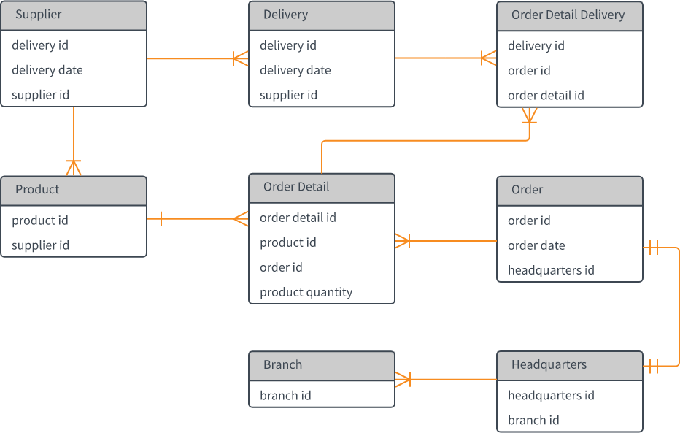

- How many foreign keys are there in the Supplier table?
  - 0 B) 3
C) 2 D) 1

Ans: C) 2

- The type of relationship between Supplier table and Product table is:
  - one to many B) many to one
C) one to one D) many to many

Ans: A) one to many

- The type of relationship between Order table and Headquarter table is:
  - one to many B) many to one
C) one to one D) many to many

Ans: C) one to one

- Which of the following is a foreign key in Delivery table?
  - delivery id B) supplier id
C) delivery date D) None of them

Ans: B) supplier id

- The number of foreign keys in order details is:
  - 0 B) 1
C) 3 D) 2

Ans: D) 2

- The type of relationship between Order Detail table and Product table is:
  - one to many B) many to one
C) one to one D) many to many

Ans: B) many to one

- DDL statements perform operation on which of the following database objects?
  - Rows of table B) Columns of table
C) Table D) None of them

Ans: C) Table

- Which of the following statement is used to enter rows in a table?
  - Insert into B) Update
C) Enter into D) Set Row

Ans: A) Insert into

Q14 and Q15 have one or more correct answer. Choose all the correct option to answer your question.
- Which of the following is/are entity constraints in SQL?
  - Duplicate B) Unique
C) Primary Key D) Null

Ans: B) Unique and C) Primary Key

- Which of the following statements is an example of semantic Constraint?
  - A blood group can contain one of the following values - A, B, AB and O.
  - A blood group can only contain characters
  - A blood group cannot have null values
  - Two or more donors can have same blood group

Ans: A) A blood group can contain one of the following values - A, B, AB and O.
B) A blood group cannot have null values
D) Two or more donors can have same blood group

